From Data to Visual Understanding

Descriptive Analytics: Data Visualization and Storytelling with Data

The previous modules of this course covered primary visualization methods for several data types and structures frequently encountered in business or finance. The modules also addressed the action and interaction patterns necessary for visual analytics. *This* module brings all these elements together into a unified analytical environment.

# Analytical Dashboarding

*Data scaffolding* consists of a data model[1], analytical transformations of the data variables, and supporting visualizations. The final component of data scaffolding is an environment that enables us to:

* Summarize the data
* Visualize multiple variables and their transformations
* Receive data updates
* Layout the information spatially

So far, the visualizations we have been building throughout this course have been focused on answering questions related to the variables at hand. We now want to use the facts, statistics, relationships, and patterns revealed by those visualizations to develop a better understanding of “what happened” from a higher vantage point.

For example, suppose you have a dataset containing real-time sales figures for all your company’s products across all stores in the U.S. Some of the stores have been experiencing increasing product sales while others have been experiencing declining sales—especially in large cities. According to a descriptive analysis of your customers’ demographics, the primary customers for your products are women between the ages of 45 and 60. This is certainly useful information, but if you want a more holistic view of the business environment surrounding these data points, you may need a wider perspective. For instance, product sales may be decreasing in urban areas because women between 45 and 60 years old are migrating from urban to suburban areas. Only by viewing data in the aggregate can you see how such exogenous factors could be influencing sales trends.

One way to implement an integrated analytics environment is via a *dashboard*. A dashboard is simply a visual display of data (or *faceted display,* in the language of the grammar of graphics) that allows you to monitor certain specific conditions and thereby develop a better understanding of the factors underlying the data. Most data analysis applications allow you to set up dashboards easily through simple drag-and-drop interfaces.

Dashboards have been an integral part of business operations since the early 1980s. Just as automobile dashboards have increased driver awareness, safety, and performance over time, business dashboards have improved strategic decision making, governance, and risk management at all levels of an organization. Business dashboards offer a variety of benefits including:

* Aligning stakeholders to a common set of key performance indicators (KPIs) and core metrics
* Consolidating data and analytics from multiple sources
* Providing a simple, clear, and objective view of information in digestible chunks.

## Focusing on Relevance

The main principles of good dashboard design apply to any type of dashboard construction. They:

* Focus on relevant data
* Reduce complexity

In order to focus on the relevant data, we first need to ask:

* What is the objective of the dashboard?
* Who is the audience?

There are many different types of dashboards, each having different objectives and target audiences. Typically, three main distinctions exist in business dashboards (Table 1).

| **Dashboard Type** | **Timeframe** | **Audience** | **Objective** |
| --- | --- | --- | --- |
| **Operational** | Real-time to short-term | Reactive short-term stakeholders such as day-to-day operators | Tactical and short-term management |
| **Analytical** | Medium- to long-term | Analysts, management | Modeling, analysis, and systematic planning |
| **Strategic** | Long-term | Long-term decision-making, strategy, and planning— typically senior management | Strategic and long-term goals |

*Table 1: Characteristics of dashboards*

Once we have a clear understanding of the requirements, there are generally two broad approaches for narrowing down the focus of a dashboard to only the relevant information:

* **Data reduction** methods narrow down the quantity of data either visually or analytically by emphasizing specific data points through either manual or automatic processing. With small datasets, analysts can interactively select the data they deem important to view. With large datasets, manual methods can be time-consuming and error-prone as drawing a distinction between data of interest and data that is less relevant can become extremely challenging. In these cases, automatic methods are sometimes preferred because the policies that specify which data is ultimately included or hidden becomes transparently explicit.
* **Feature reduction** methods, which generally comprise a form of *feature engineering,* focus on identifying the variables that provide the most amount of information. In feature engineering, subject matter experts make use of their domain knowledge when manually selecting data and dimensionality reduction techniques for automatic or computational data selection. In the design of descriptive analytical dashboards, feature reduction is akin to ranking features of interest, which may or may not contain the most information or make the greatest contributions to observed variances. While lower-ranked features are not eliminated, they are typically masked from view. In our automobile analogy, certain engine performance measures are not displayed, such as oxygen levels, air/fuel ratios, and throttle positions. However, the driver can still evaluate the state of the engine through those measures that are available, such as engine temperature, RPM, and voltage.

### Data Reduction

The manual approach to data reduction depends on filtering or brushing for isolating points of interest. Typically, the boundaries are set arbitrarily based on visual cues. This can be a disadvantage as the boundaries might not be precisely defined or repeatable.

#### A dynamic example of automatic data reduction

*Figure 1: An example of automatic data reduction.*

Figure 1 demonstrates automatic data reduction, in which data-mapped aesthetics are filtered, brushed, or changed without manual intervention. The advantage here is that we can explicitly define the boundaries. Conceptually, we create a degree of interest (DoI) method that calculates the relevance of every data point by using a DoI function to map the data elements to relevance values. Using an appropriate threshold, we can automatically eliminate or visually dim less relevant values. This approach can often highlight or reveal interesting data rankings.

The process is set up in three steps:

1. **Definition of relevance components.** First, the user defines functions that compute the relevance value of each data element. For a focus node $n_{f}$, we calculate the degree of interest of a node $n_{i}$ as follows:

$doi(n_{i,}n_{f}) = dist(n_{i}, n_{f}) + api(n_{i})$

Where $doi(n_{i,}n_{f})$ denotes the degree of interest of point i relative to f, $dist(n_{i}, n_{f})$ is a user-defined distance measure between the point i and the focus node f, and $api(n_{i})$ refers to the a priori interest level in i. This is basically saying that the degree of interest in a datapoint *i* is inversely proportional to its distance from the datapoint we are interested in. The closer it is, the higher its relevance ranking (and the lower the degree of interest, with lower values being of higher interest).

1. **Combination of relevance components.** The second step is to construct a comprehensive DoI function by combining the relevance components. This can be any function that takes two or more relevance values and returns a combined value such as a weighted sum.
2. **Specification of relevance propagation.** The final step is to determine a propagation method that distributes the relevance to related data in other variables. This could be semantic propagation along related features, structural propagation along a graph or map, temporal propagation across time, or statistical propagation with correlated data. In this way, we can map new values not yet ranked in step 1 or we can associate other variable data points.

In network analysis, graphs are often very dense and hard to decipher. We could filter out nodes programmatically to limit the view to subgraphs of interest, but highlighting using the above data reduction technique can quickly illuminate portions of the graph that are of relevance to our visual query (and show us the filter parameters, as well). For a graph, the relevance component could be a function of the number of hops needed to go to a node of interest with a threshold of two hops (with at least one path to the node).



*Figure 2: Example of highlighting nodes using data reduction technique*

The highlighted nodes in Figure 2 show us the subset graph of interest relative to a particular node. We can then:

* Extract the subset and focus the analysis on the subset or on comparisons to the subset
* Exclude the other data entirely
* Exclude the subset in focus and then analyze other data points

These actions are not destructive. They merely let us set aside subsets of data to focus on what is relevant.

### Feature Reduction

The goal of feature reduction is to select the minimal set of features that capture meaningful data characteristics. The visual analysis can then concentrate on dimensions and measures rather than on individual data elements. Typically, feature reduction for dashboard analytics is done in consultation with a SME and is based on some prior knowledge of the features that are in fact important.

The process is typically as follows:

1. **Feature specification**: First, we identify the features that are of interest and note specifically *why* they are interesting. Selecting these features is highly dependent on the objective of the dashboard and the types of features available. For instance we may be interested in *temporal features* (those that change over time), *spatial features* (those that occur next to each other in terms of physical location—including geographically), or *statistically related features* (those that are mathematically related to each other through a statistical association).
2. **Feature extraction**: Next, we extract the selected features from the data and constrain them as needed via data reduction such that both the feature and the data are focused on those aspects that are of greatest relevance.
3. **Feature visualization**: Finally, we prioritize our focus by ranking the features in order of importance so we can create an appropriate and informative visualization.

Feature reduction:

* Provides a higher level of analytic abstraction because it forces us to consider the minimal set of features that capture variances in the dataset
* Provides clearer and less cluttered visual representations because the number of features is much smaller than the number of data elements

## Reducing Complexity

The second principle of analytical dashboard creation is reducing complexity. As a dataset increases in size toward “big data” levels, visualizations will invariably become indecipherable and thus carry no informational value. Consequently, reducing a dataset’s complexity is important for ensuring that any visualization created from that data provides useful information.

### Abstracting Data

Because only a finite number of pixels can be displayed on a computer screen or printed page, it is entirely possible for multiple data values to be mapped onto a single pixel. This is called *overplotting* (see Figure 3).

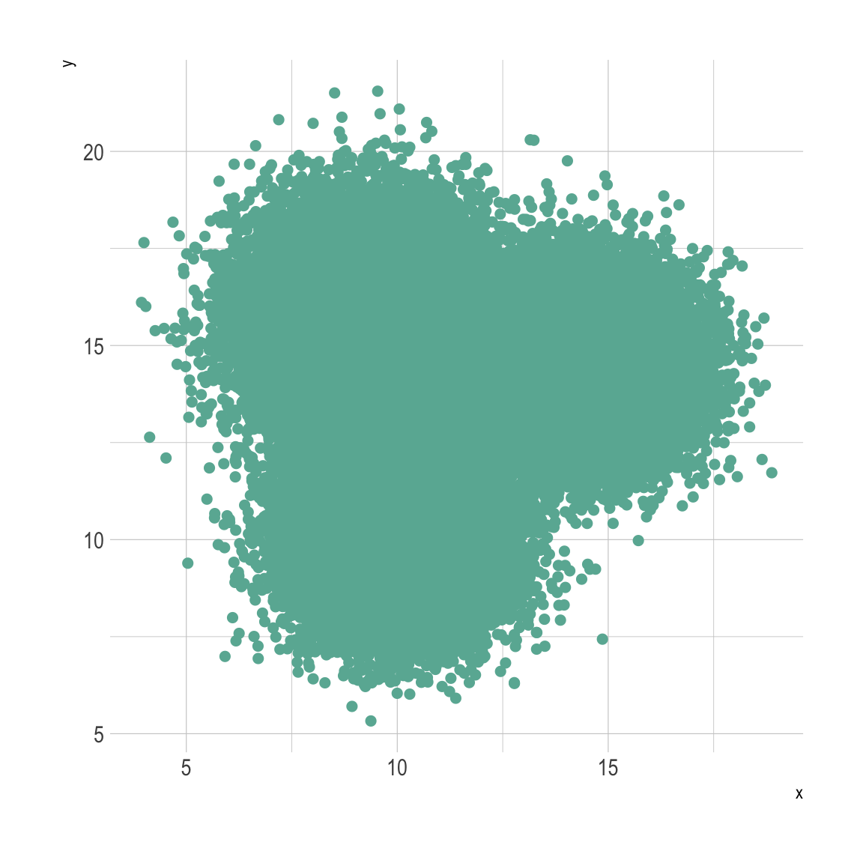

*Figure 3: Example of severe overplotting. Notice that the data points are so dense that it is impossible to see any features or detail in the plot.*

Large volumes of detailed information can quickly overwhelm plots of any type. At a meta-level, large numbers of plots, tables, and other information can quickly overwhelm a dashboard. The challenge is determining which of the values should be visualized in the available space. There are two main ways to abstract the data:

* Use a *sampling method* to choose a subset of the original data. Sampling in this case refers to any method that automatically selects a data subset such that the original characteristics of the larger dataset are preserved. Depending on the situation, this can be a standard statistical sampling method, an equidistant sampling method, or even sophisticated graph sampling. For example, three separate groups of data emerge when plotting samples randomly drawn from a dataset (Figure 4). However, Keep in mind that one of the challenges with sampling is that the sample may not accurately capture or reflect underlying features, especially when you want the visualization to capture those features.

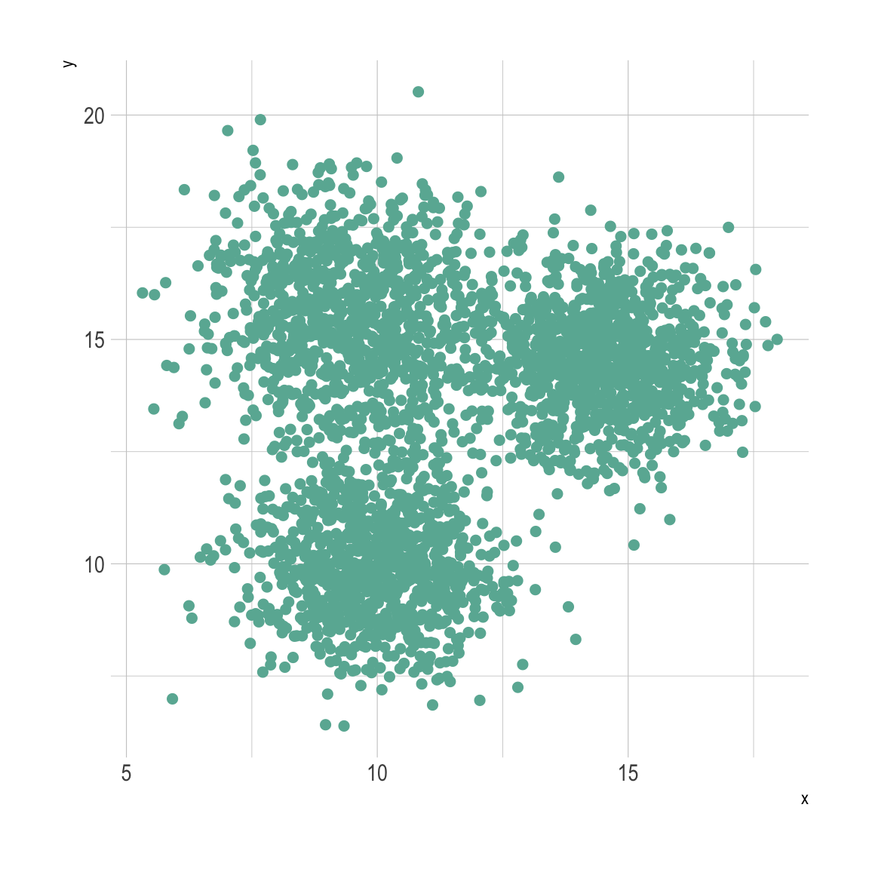

*Figure 4: An example of a sampling method showing the emergence of three separate groups.*

* *Aggregation methods* combine and reduce multiple data values within an interval by summarizing them in terms of their statistical characteristics. These characteristics include the following values for the dataset: minimum, maximum, count, sum, average, median, mode, number of unique values, standard deviation, etc.

Figure 5 shows how each point can be mapped to a small region which now scales saturation and transparency according to the number of values in the region. Over increasingly finer scales, this becomes a density map, which makes it easier to see the relationships and distributions of the points in the scatterplot.

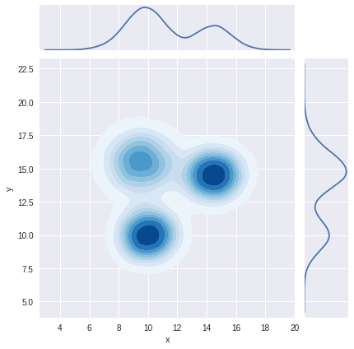

*Figure 5: Example aggregation method showing the relationship and distributions of points in a scatter plot.*

Data abstractions simplify data by considering single representative values over an interval through sampling or aggregation (Figure 6). The resulting plots provide much clearer views at a minimum level of specificity.

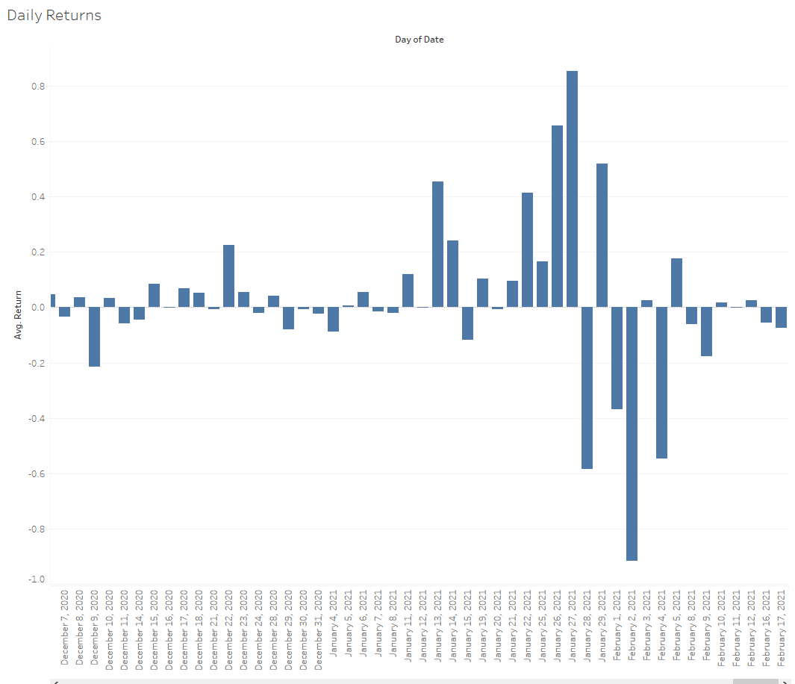

*Figure 6: Example visualization of data abstraction*

In many business use cases, we may only need a coarse view of, say, average returns. We can aggregate daily figures and obtain quarterly averages, which provides a more focused view that helps us understand past trends (Figure 7).

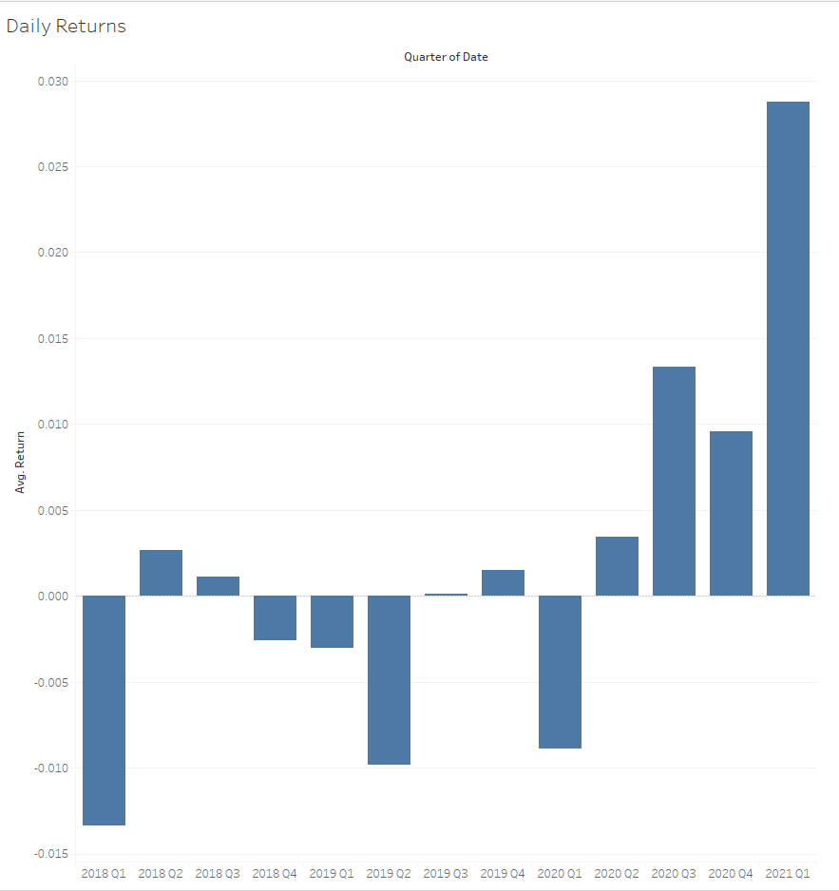

*Figure 7: Example visualization of aggregated data to a simplified view*

### Grouping

*Grouping* simplifies data by dividing the data space into partitions and then aggregating the data according to those partitions. Classification and clustering are two common approaches for grouping data.

* **Classification**: In manual classification, the analyst specifies partition boundaries to divide the data set. For example, we might split our dataset into two groups consisting of (1) sales data *before* a sales discount is applied and (2) sales data up to one month *after* the sales discount goes into effect. Automatic methods such as decision trees can also be used. Classification subdivides the data space where each subspace is assigned to a particular class. Data elements within each class share similar characteristics, data generation environments, or assumptions. Classes can also be arbitrarily defined during model development where data might be split into test and training sets.
* **Clustering**: Clustering also groups data into subsets or subspaces and there is no conceptual or procedural difference in manually creating the groups. The difference arises when using automatic methods, which has more to do with the underlying algorithmic approach (such as using unsupervised methods like k-means).

Let’s return to our earlier overplotting example and perform a hypothetical grouping (Figure 8).

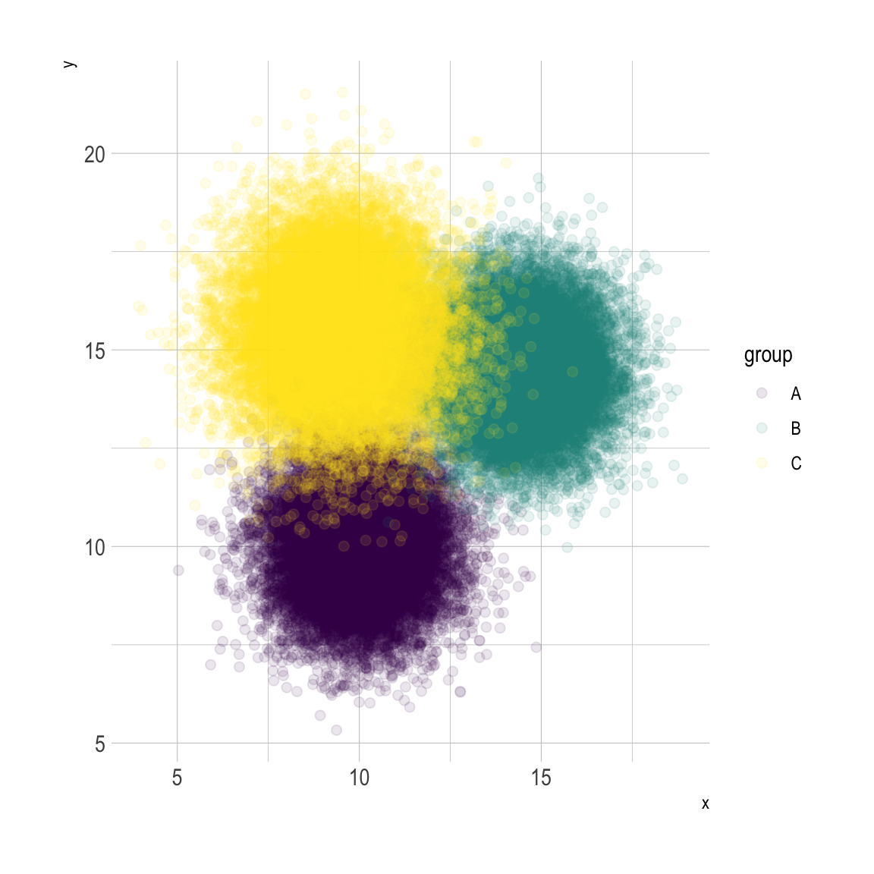

*Figure 8: A hypothetical grouping of overplotted data*

Grouping information may or may not be provided for a dataset. Manual grouping would certainly be difficult for datasets where clear partitions are not available. Automatic grouping for classification or grouping without predefined labels is considered a challenging unsupervised learning problem.

## Putting it Together

After the target audience, objectives, and principles have been clearly defined, creating the dashboard itself is less of a technical exercise and more of a design challenge.

### Process

While there is no one right way to create a dashboard, there are benefits to following a systematic approach such as this one:

1. *Define the objective of the dashboard and the core audience*. This is absolutely a fundamental requirement for creating an effective display. The objectives narrow down the scope of analytic exploration and knowing the audience constrains the complexity and focus of the visualizations. Together they focus on what is relevant and how should it be presented.
2. *Identify the key metrics and rank their level of importance.* Identifying the audience and the objectives allows us to define the key metrics that the stakeholders find relevant. At this stage, we should be able to rank the metrics in terms of priority and apply both data and feature reduction to tightly define the feature and data spaces.
3. *Choose the visualizations that best help your audience focus on the relevant metrics*. The initial visualizations created during preliminary data exploration are seldom sufficient to help the audience gain familiarity with the data. By reducing the complexity of the visualizations, important information can be communicated more efficiently.
4. *Use the grammar of graphics to define the aesthetics, layout, and flow*. As you know, the grammar of graphics maps data to visual elements. Similarly, the same concept can be applied at a metalevel to the visual elements of a dashboard. Graphs, tables, and figures can be mapped to position, size, and color scales in order to emphasize their relative level of importance.
5. *Simplify and iterate*: Dashboards are never quite finished. Important metrics constantly change. The importance ranking of certain information may fluctuate. The audience and objectives may shift. More effective visualizations and delivery mechanisms present themselves. Dashboard designs are constantly revised and simplified.

### Considerations

It is easy for a dashboard designer and analyst to become lost in the data or in the design process itself. Fundamentally, dashboard design requires constant evaluation of:

1. **Objectives**
   * Is the dashboard for operational, analytical, or strategic use?
   * How do I present the minimum amount of information while ensuring that it is the most relevant?
2. **Time requirements**
   * What is the attention level required to process or view the information?
   * How much interactivity is required to see what is important?
3. **Audience**
   * What understanding of the data or domain do they already have?
   * Are there any accessibility constraints?
   * How will they view the information (print, digital, web, mobile, etc.)?

These considerations are often left by the wayside. The objective of descriptive analytics is to help communicate “what happened” not just for the analyst, but for a larger audience. Visual analytics are most effective when a dialogue can form around the visualizations that subsequently sparks action, informs decision making, or fosters a shared understanding of the reasons underlying “what happened.”

1. *Data model* here refers to the abstraction of relationships and entities within the dataset and how they map to the domain. It does *not* refer to the database notion of data models or the logical data model of a query language.